How to use plan metric comparison tools in CERR, and hints on adding your own metrics (ver2)
J Deasy, 13 June 05.
LM: 4 Jan 06.

(This applies to versions 2.5 and 3.0.)

All metrics are stored as separate .m files under the ../planMetrics/ subdirectory. These metrics are available for plan analysis through a GUI which can be activated under the metrics menu (see Fig. 1).

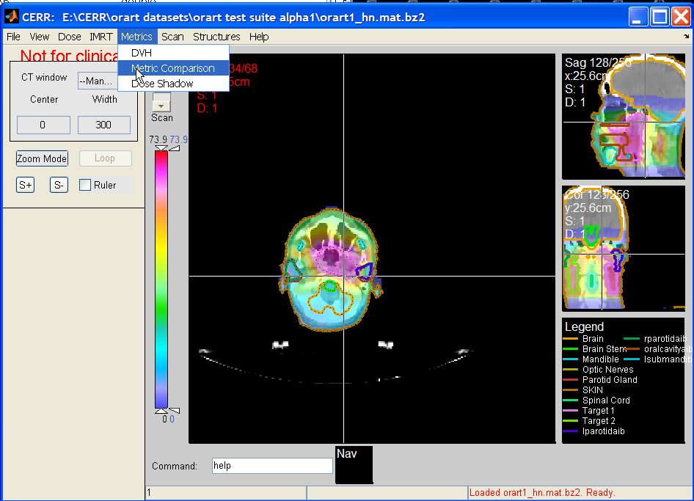
Fig. 1. Selection of the metric comparison GUI. The example plan is the CERR H&N example 1 file from the web page.

If the code is correct, the new metric will appear in the list with the other metrics when the metric comparison GUI is invoked (see Fig. 2).

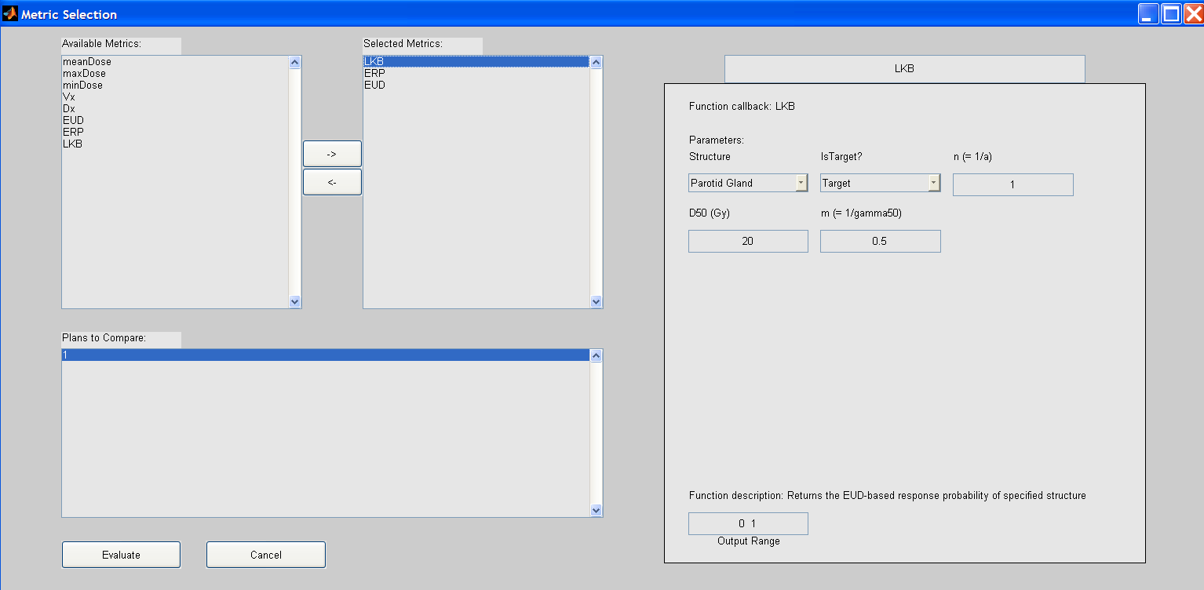
Fig. 2. The metric comparison selection GUI. A metric is chosen to be applied by selecting from the list at upper left and clicking the right arrow. The parameter for the metric are show in the right hand side. WARNING: just editing a text box will not change the parameter value. The return key must be pressed for any changes to take effect. The metrics will all be applied to all the dose distributions which have been selected in the lower left list box (only one dose distribution exists in this case). Note: dose distributions must be decompressed for metric evaluation.

Typing evaluate on the metric selection GUI will result in a graphical comparison of metrics, such as the simple one shown below (Fig. 3).

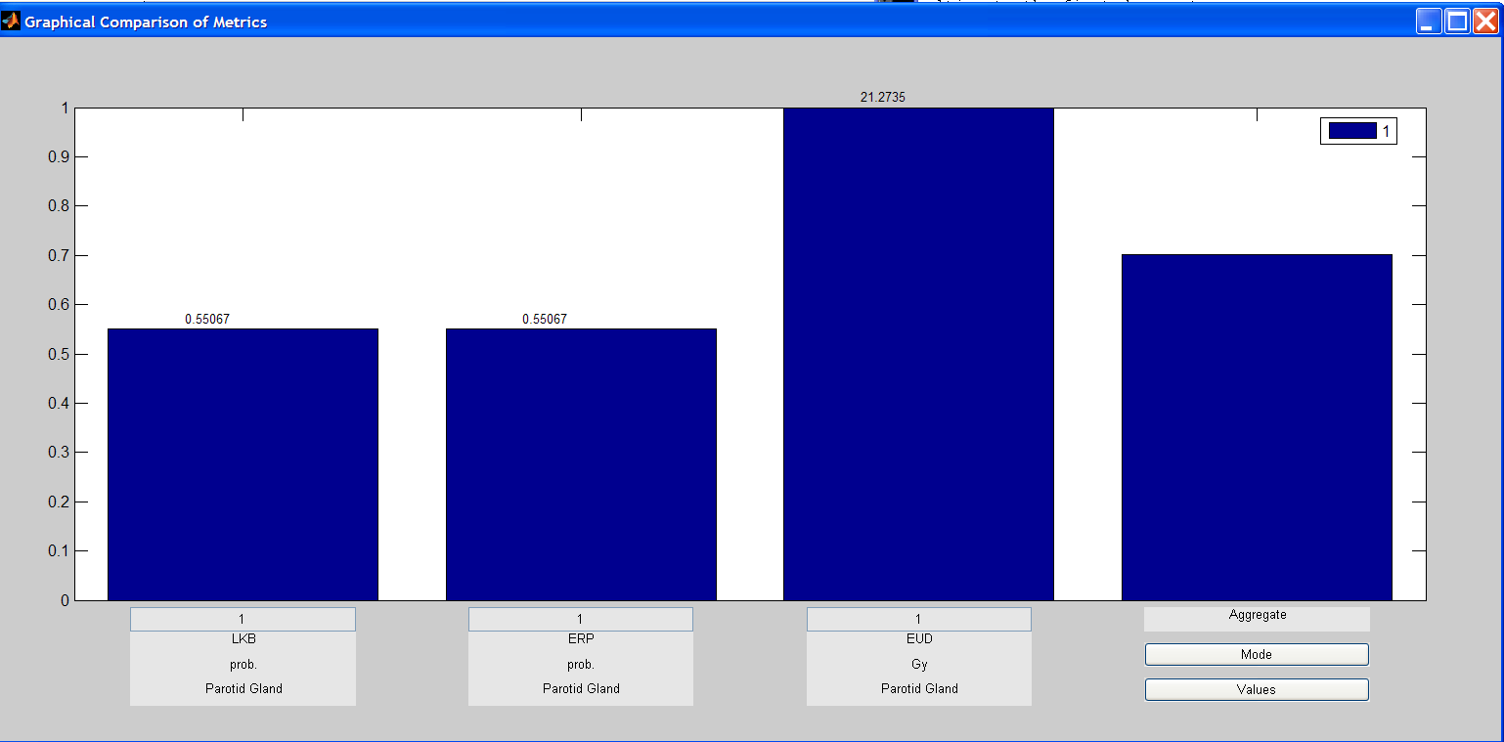
Fig. 3. A simple comparison of three metrics for a single dose distribution. The last column on the right is an equally weighted mean of all the metrics for all the dose distributions (one in this case). For targets, higher metrics are assumed to be better, and for non-targets, lower metrics are assumed to be better. Plot bars are higher for better metrics.

Another example: EUD

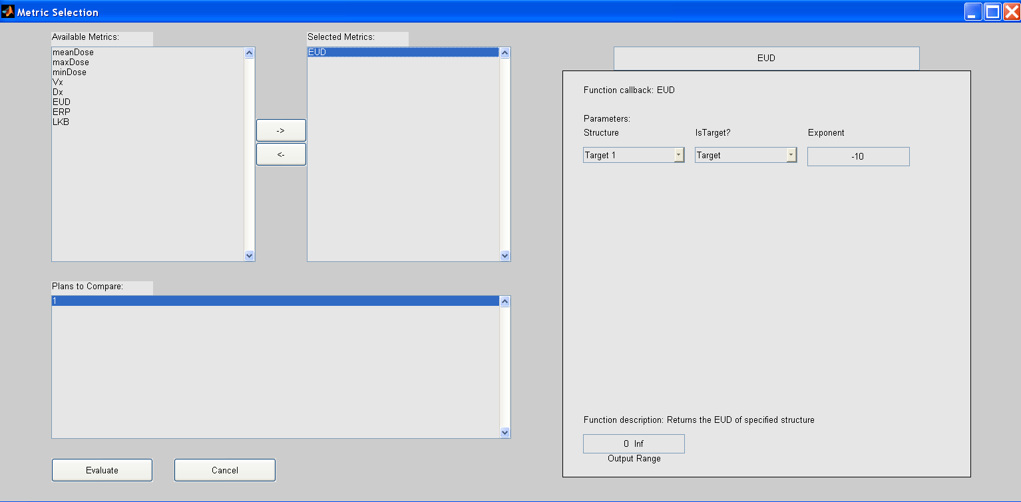
Fig. 4. Specifying the EUD from the metric comparison tool GUI. EUD can also be invoked at the command line (see below)

We intend to continue developing the CERR metric evaluation interface over time.

Adding a new plan metric

To write the new outcome model, it is probably best to modify a similar existing metric .m file, under the ../planMetrics/ subdirectory. There is also a template-like example file which may help.

To test the new metric, place the metric.m file into the ../PlanMetrics/ subdirectory. Also edit the CERROptions.m file to include the name as a legitimate metric (see Fig. 5).

Fig. 5. Inclusion of the new metrics into the CERROptions.m file. Just edit the opts.planMetrics line to add the new metric name in single quotes.

Calling the metrics from the command line or scripts

To call metrics from command lines or scripts, you need to supply the appropriate parameters. To get the parameter list, invoke help:

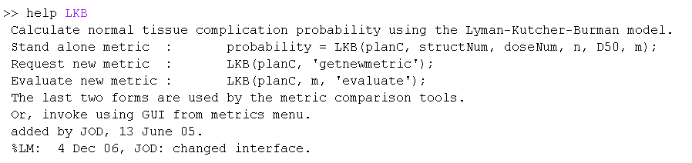
Fig. 6. Using the help function to determine metric calling parameters.

Once you have determined the response parameters, you can call the function from the command line, as shown in Figure 7.

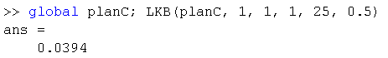
Fig. 7. Compute the Lyman-Kutcher-Burman complication probability.

The ERP model: EUD-based response probability

My personal preference is to view the LKB model in a more general way, by emphasizing the role played by EUD (what is also known as the ‘generalized mean’). This is the same as LKB except the inputs have been made more intuitive:
- Instead of m as the slope parameter, ERP uses gamma50,
- Instead of n as the exponent, ERP uses the EUD input parameter, a.

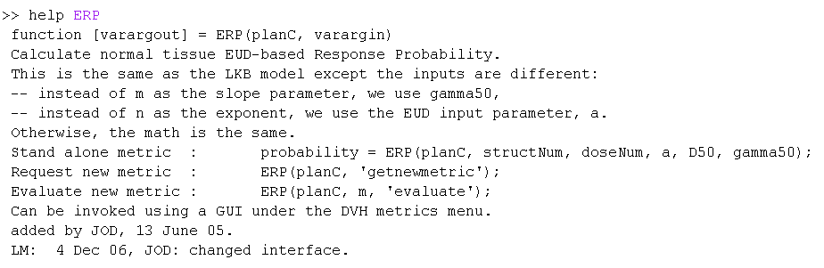
Fig. 8. Help for the EUD-Response Probability model. This is the same as LKB except the inputs have been made more intuitive.

